**Ex. 6. JavaScript – Timer Functions and Objects**

**URK17CS127**

**Date:**

1. Write JavaScript code to display digital clock.

# <h1>Digital Clock!</h1>

# <span id="time"></span>.

# <script>

# //define function display

# //call the time display function for every one second

# </script>

// get time

var d= new Date();

// extract hour,minutes and seconds

d.getHours

d.getMinutes()

d.getSeconds()

// call the time display function for every one second

setInterval("display()", 1000);

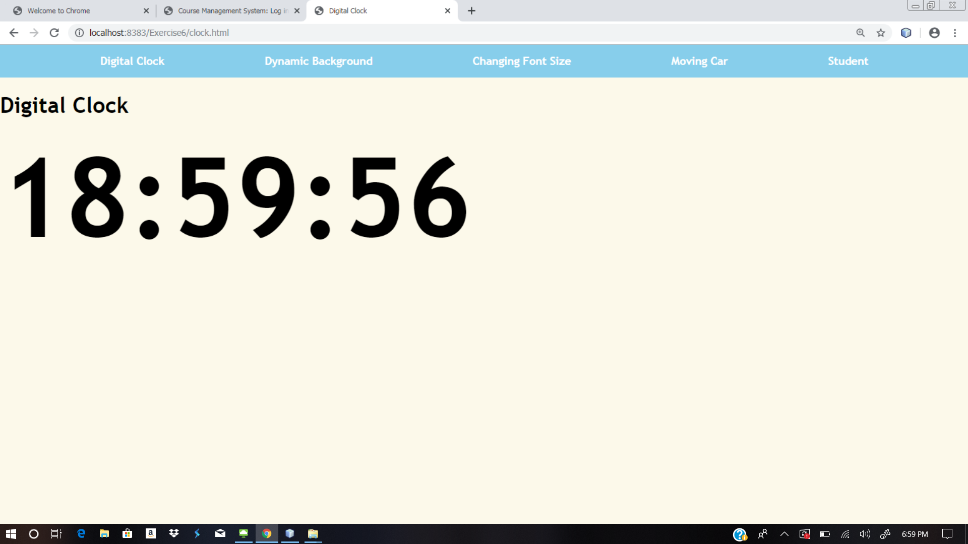

1. Write JavaScript code to change background colour for every 30 seconds.

# <body>

# <h1>Dynamic Background!</h1>

# <script>

# //define function setBackgroundColor

# //call the setBackgroundColor function for every two seconds

# </script>

# </body>

//create random colors using rgb function

var red = Math.floor(Math.random()*255);

var blue = Math.floor(Math.random()*255);

var green = Math.floor(Math.random()*255);

var color= "rgb("+red+","+green+","+blue+")";

// change or set body background color

document.getElementsByTagName("body")[0].style="background-color:"+color;

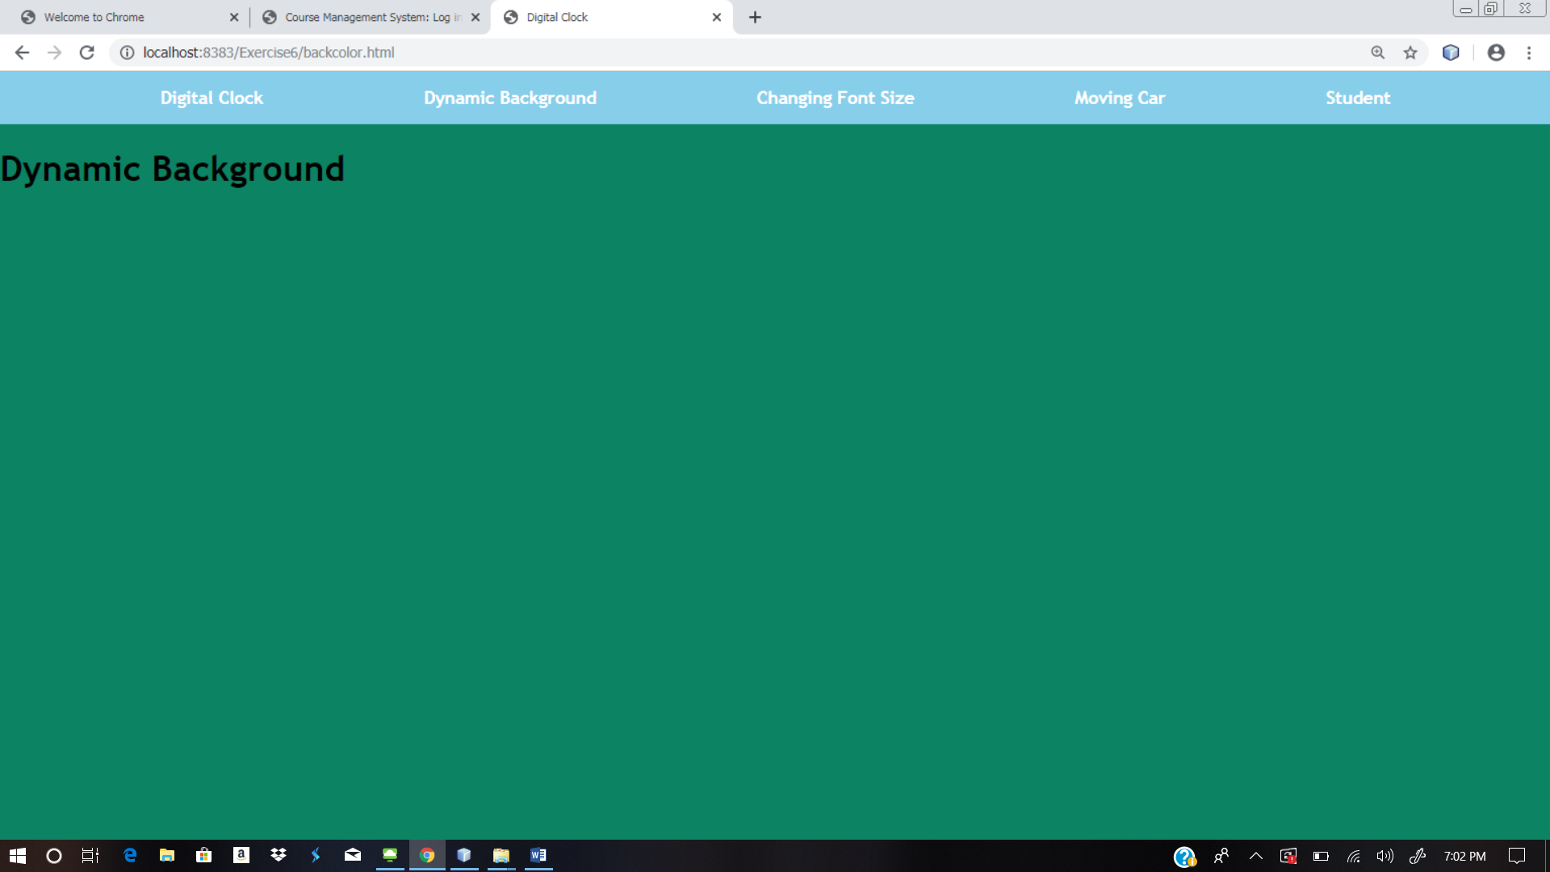

1. Create event handlers that will increase the font size when a mouse moves over a paragraph and decrease the size when the mouse moves off the paragraph.

# <h1>Change font size!</h1>

# <p id="para1" onmouseover="incSize()" onmouseout="decSize()">

# move cursor over me to zoom in...

# </p>

# <script>

# //define function incSize

# //define function decSize

# </script>

# </body>

// To change font size

function incSize(){

document.getElementById("para1").style="font-size:28px";}

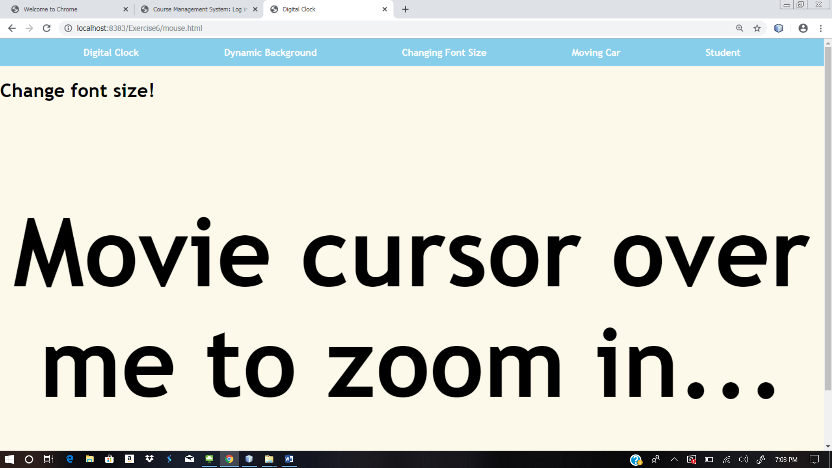

1. Write JavaScript code to move absolutely-positioned car image when a user clicks the move button and stop the car image when a user clicks the stop button on the following webpage.

//sample code to move image

function init()

{

imgObj = document.getElementById('img');

imgObj.style.position= 'relative'; imgObj.style.left = '0px';

}

function moveRight()

{

imgObj.style.left = parseInt(imgObj.style.left) + 1 + 'px';

animate = setTimeout('moveRight()',10); // call moveRight in 20msec

}

function stop()

{

clearTimeout(animate);

imgObj.style.left = '0px';

}

window.onload =init();

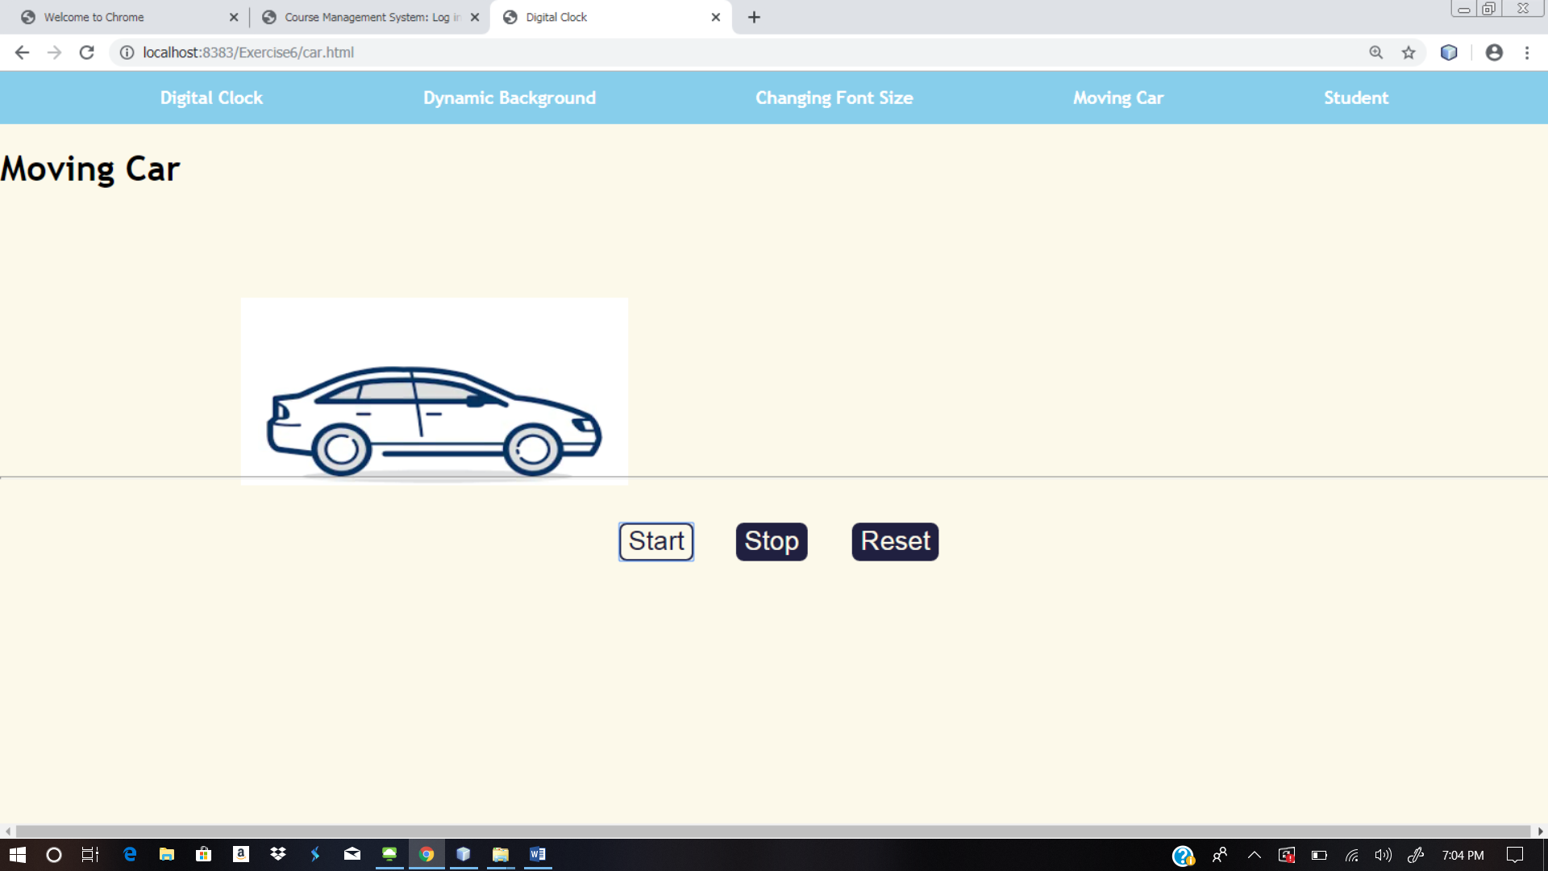

1. Create an array of objects, where each object describes about a student and his/her properties for the name (a string), regno (a string) and year of birth (a number). Iterate through the array of students and display it on the web page. For each student, print the student name and register no like so: "John’s Register Number is UR13CS129". Now use an if/else statement to categorize the students they have date of birth before 2000 and after 2000.

// Create an array of objects

var student = [ { name:'John', r_num:'123', dob:'20-apr-1995' }, { name:'Joseph', r_num:'456', dob:'05-jan-1998' }];

//Iterate through an array

for (var i = 0; i < Objectname.length; i++) {

//access property

Objectname[i].property1;

//student[i].name;

}

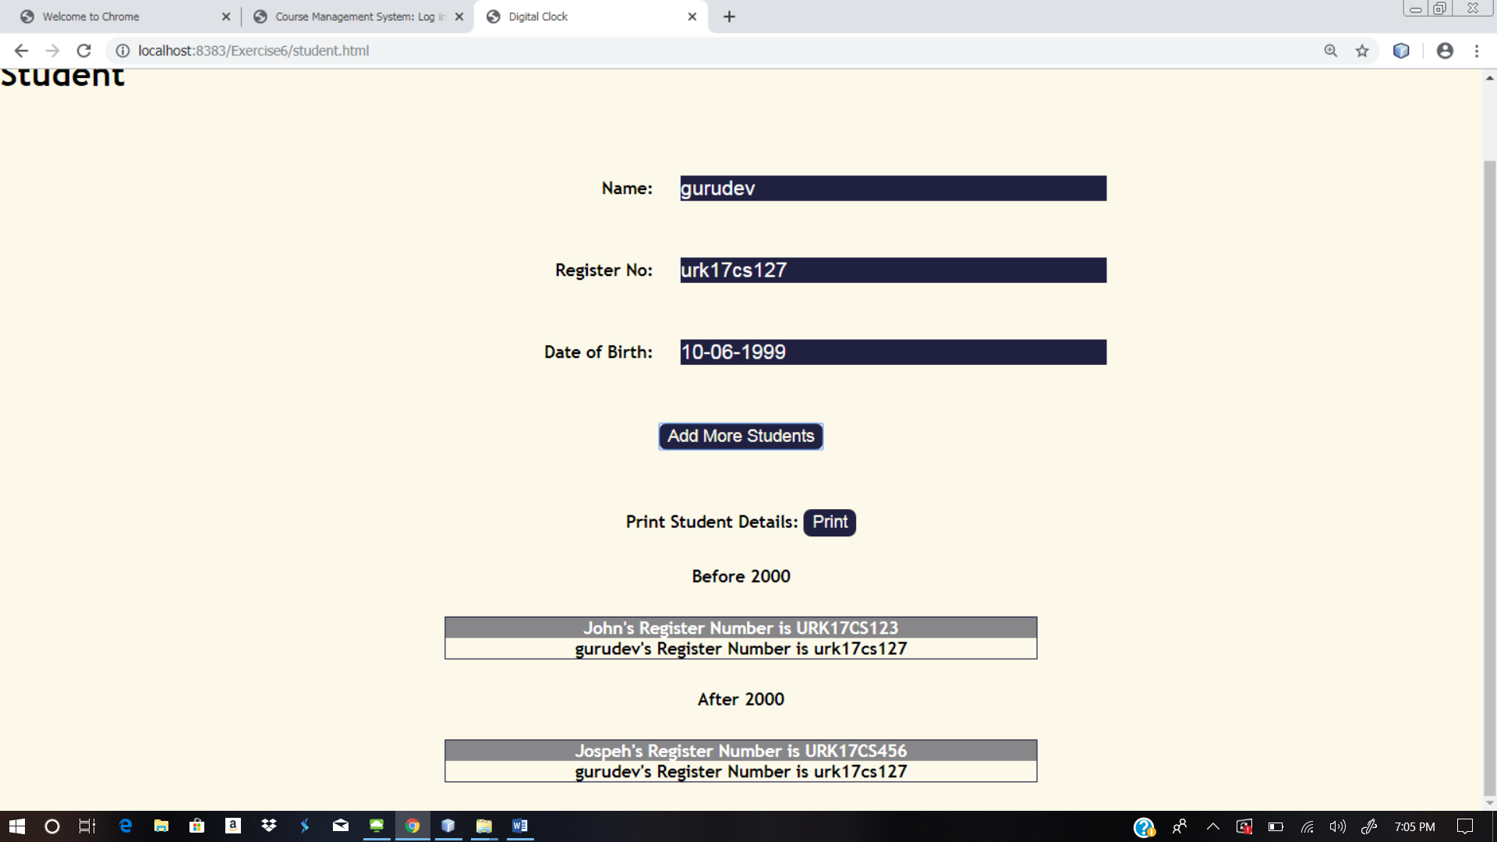

**Web site URL:** <http://urk17cs127.rf.gd/Exercise6/>

**You tube URL:** [**https://youtu.be/A7AR3kdHmwg**](https://youtu.be/A7AR3kdHmwg)